Python – object oriented program , Guido van Rossum, 1989

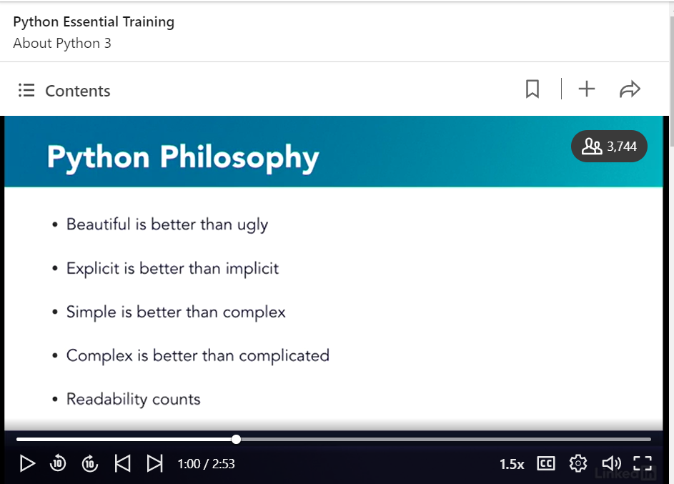

Python 3 – not backward compatible

In python 2 – it does not need parantasis and it is a keyword, where as in python 3, it is a function and requires a paranthasis

In python 3 there is only one integer type and all text is Unicode but in 2 there was diff ascii, Unicode, data

Print is a function in Python 3 and a keyword in Python 2.

Each print statement will print its output in a separate line.

UTF-8 and Unicode are actually used to represent data in non-English languages.

* Why is UTF-8 a good choice for the default editor encoding? == The Unicode character set in the editor should match the Unicode standard of Python 3.

Correct

The character set of the editor should match Python's Unicode compliance.

A shebang line starts with a hash mark, immediately followed by an exclamation point.

Which line is an expression but NOT a statement?

* x=x+1

Incorrect

This is a valid line of code, and is therefore both an expression and a statement.

* True

Correct

This expression is not a stand-alone line of code.

What will this code produce?

a=5 if a > 0: a=6 print('a is {}'.format(a))

* It will print a is 6.

Correct

With the condition being true, the variable a will get a new value.

* It will print a is 5.

Incorrect

Since the condition is true, the variable a will be updated and will no longer be 5.

In Python, a statement is _____.

* a line of code

Correct

When a return value is not specified explicitly, a function returns a none value.

To run python file : python filename.py

#! -> is used to give a path for python interpretor

The main function at the bottom - Forces the interpretor to read the entire scripts before it executes any of the code.

In pyhon functions need to be defined before it is called.

X=44

print(‘Hello world {}’.format(x)) #output: Hello world 44

print(‘Hello world {} and {}’.format(x,y)) #output: Hello world 44

if x<y:

print(‘dkjsnccjdnj’)

elif x>y:

print(‘ncncncnc’)

elif x=y:

print(‘ncncnc’)

else:

print(‘mnmnm’)

words = [‘one’, ‘two’, ‘three’]

for i in words:

print(‘’nv’)

In python class is a definition and obj is a instance of a class

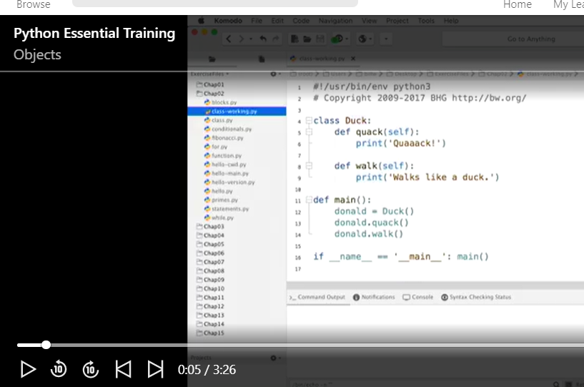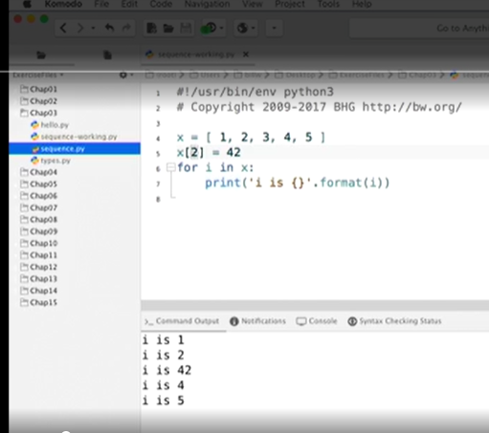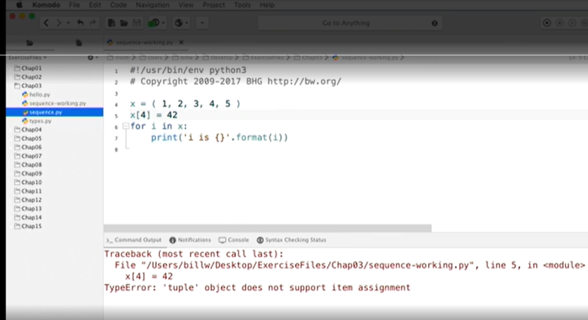

x = range(10) # 0,1,2,3,4,…..9

y = range(5,10) # 5,6,7,8,9

z = range(5,50,5) # 5,10,15,20,….50

x = list(range(10)) # [0,1,….]

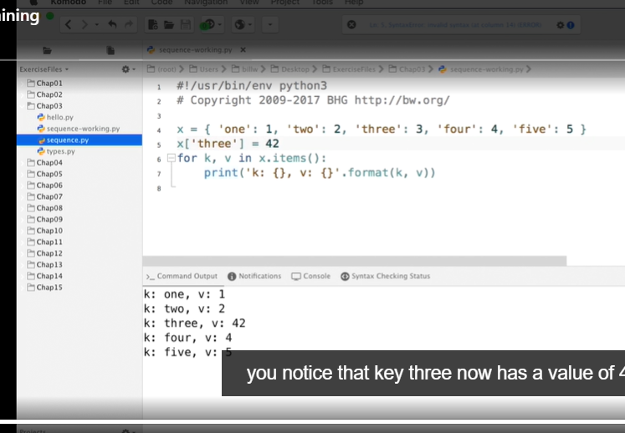

List and dictionary are mutable, but not the tuple

Note: In python, everything is a class. Example list, tuple, dictionary

Isinstance | id | type

* id(a[1])==id(b[3])

Correct

Since the referred items are pointing to the same immutable string, they have the same id.